MICT – Pallet Link Merge

**Project Identification**

|  |  |  |
| --- | --- | --- |
| **PR Number:** | **Business Analyst:** | **Date:** |
|  | Rodolfo Cabada | 08/07/2018 |
| **Region:** | **Business Unit:** | **Requestor:** |
| Americas | Engineering Manufacturing | Hector Lopez |

|  |  |  |  |  |
| --- | --- | --- | --- | --- |
| **Application Name** | MICT | | | |
| **Functional Owner** | Ivan Flores | | | |
| **IT Owner** | Jaime Anchondo | | | |
| **Supported Business Process** | |  | | |
| **Criticality of supported Business Process** | | Low  No direct impact on production | Medium  Limited impact on production, workaround available as alternative if this process stops | High  Significant impact on production, no workaround available, If this process stops, production stops |
| **Is there an alternative system in other locations?** | | Yes  No | | |
| **Description of alternative:** | | Currently the linked of the PCB’s with the pallet is done through the Pallet Link application, if the implementation fails, this workaround will continue to exist. | | |
| **Reasons why alternative is not acceptable:** | | Performance problems  Complexity  Others: | | |
| **Reason of requirement** | | Legal | Customer | SOX |
| Others: | | |

Change History

|  |  |  |  |
| --- | --- | --- | --- |
| **Name of BA** | **PR/IN number** | **Date** | **Description and Page reference (mark with color and use ‘track changes’** |
| Rodolfo Cabada | NA | 8/07/2018 | Initial requirements |
|  |  |  |  |

Document References

|  |  |
| --- | --- |
| **Document Title** | **Link to document** |
|  |  |
|  |  |

Table of Contents

1 Business Reason and Purpose of the Application 4

2 Acronym List 5

3 Solution Overview (High Level) 5

3.1 Description of the Process and Summary of Improvements 10

3.2 Output list 10

3.3 Interfaces 10

3.4 Error Handling 10

4 Authorization Requirements 10

5 Prerequisites 10

6 Hardware / Network requirement 11

7 Test Plan 11

# Business Reason and Purpose of the Application

Manufacturing Engineering department requested a new enhancement for the MICT application due to the implementation of the SFMM v2 in customer TESLA. The current manufacturing process in the stations ERSA / Wave Soldering include the use of an application called “Pallet Link” to do the linking of the PCB’s with the pallets validating certain things before being able to do it, for example: the maintenance of the pallet.

The need consists in the merge of this process with the MICT functions (required by the SFMM) to associate the component / GRN traceability with the serial numbers processed in ERSA / Wave Soldering. This merge will help to avoid multiples scanning for the same PCB serial, so with a single scanning the new application will create the Pallet Link operation as well as the MICT. Otherwise, the ERSA operator had to scan the same serial number on each application

The requirement also consists in be able to use the MICT functions without the Pallet Link process or just the Pallet Link process without the MICT functions or both together, this must be possible to configurate.

The following screenshots show the User graphic interface of the Pallet Link application:

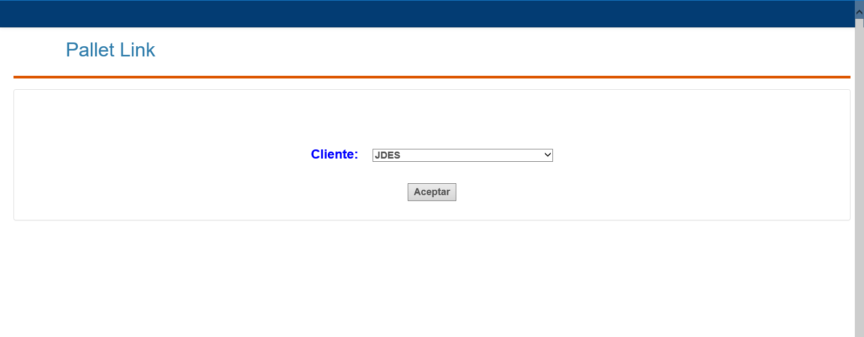

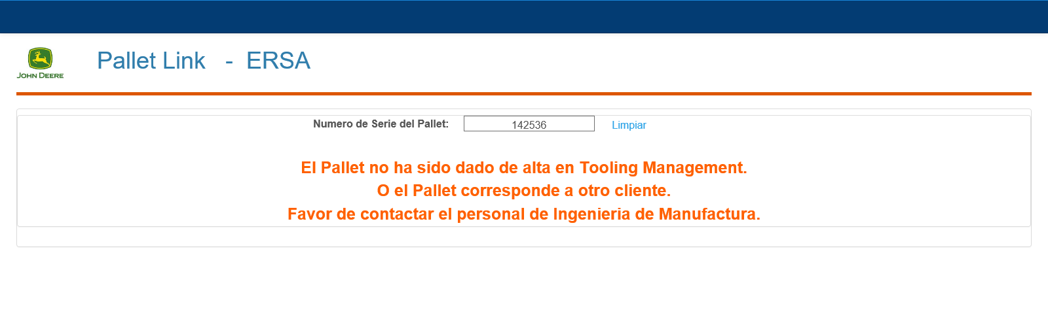One of the validations that are made before the linking are:

* The pallet exists
* The pallet corresponds to the selected client.
* The pallet has the preventive maintenance on time.

# Acronym List

List all the acronyms that are used in this document and not straight forward.

|  |  |
| --- | --- |
| **Acronym** | **Description** |
| MICT | Manual Inline Component Traceability |
| MES | Manufacturing Execution System |
| GRN | Good Receipt Number |
| SFMM | Shop Floor Material Management |
| ERSA | High-end reflow soldering system with thermal performance control and energy balance. |
| PCB | Printed Circuit Board |

# Solution Overview (High Level)

The solution proposed consists of the following:

1. Implement the linking option into the User graphic interface of MICT.
2. Implement the source code into the MICT following the same logic from Pallet Linkg application.
3. Test and debug.
4. Bug fixes.
5. Validate the solution with the client.
6. Implement the application into production environment.

**System Architecture**

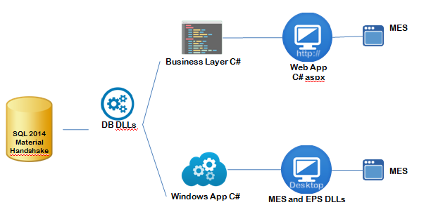**MICT – Pallet Link Merge**



**SQL 2014**

**MEWarehouse**

**User graphic interface proposal**

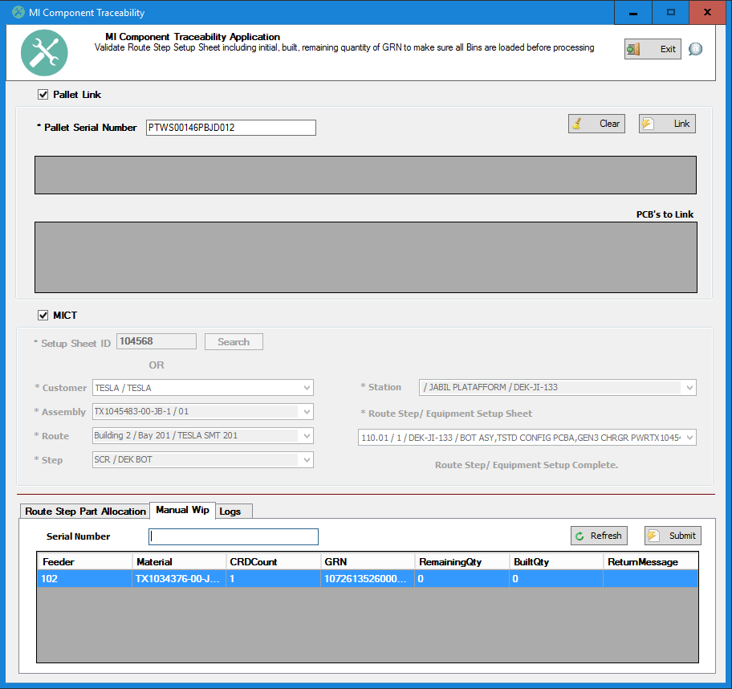

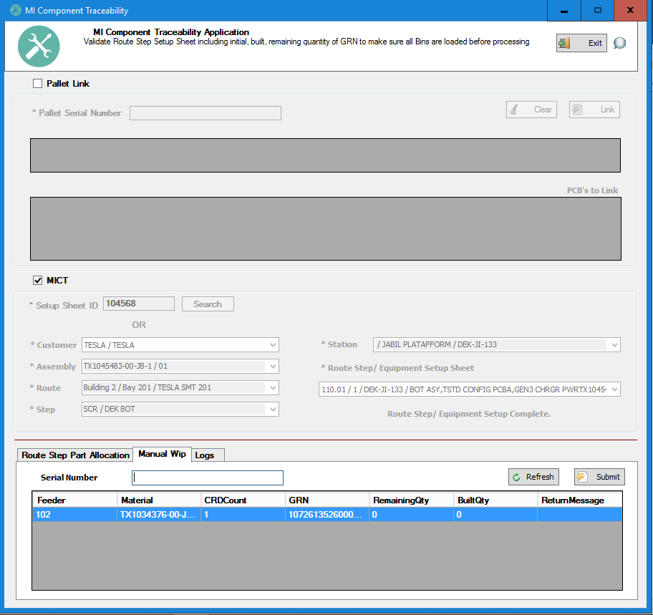

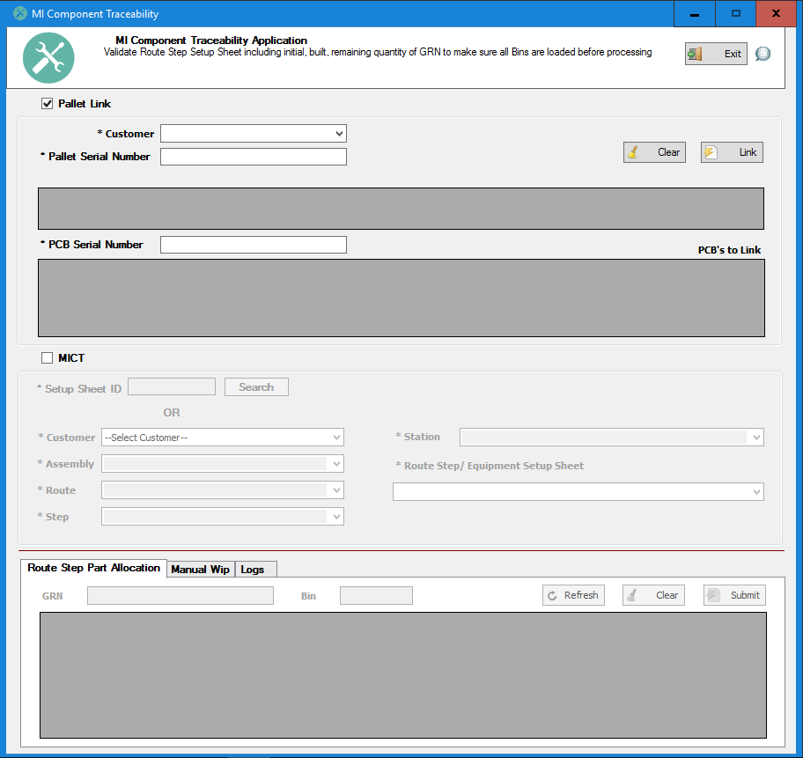

**Flow chart**

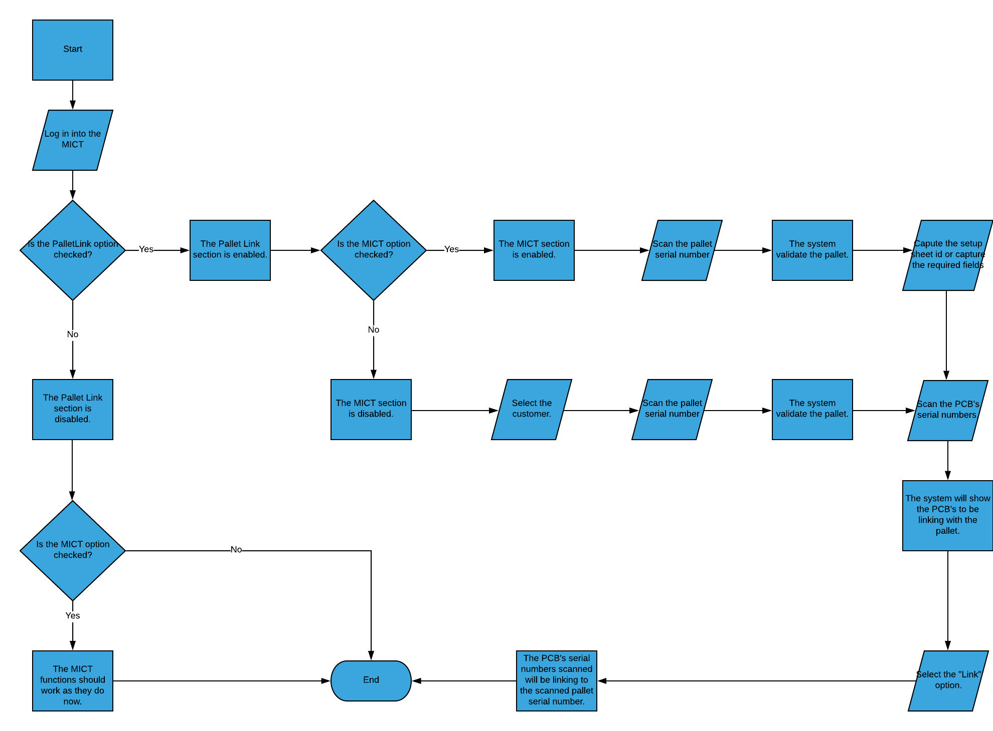

**Project Plan**

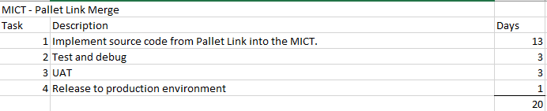

## Description of the Process and Summary of Improvements

The following improvements will be made:

1. The merge of the Pallet Link process with the MICT functions will save time because in a single process, what was previously done in two processes with two separate applications will be carried out.

## Output list

|  |  |  |  |
| --- | --- | --- | --- |
| **Field name on the output list** | **Source ID referring to item listed in the detailed execution logic** | **Length of the output file** | **Comment** |
| MI_Component.exe | Executable file | 300 KB AVG | N/A |

## Interfaces

N/A

## Error Handling

The error handling will be manage by:

|  |  |  |  |
| --- | --- | --- | --- |
| **Field name or screen name** | **Condition** | **Message** | **Message type (Error, Warning, Information)** |
| Serial number of Manual Wip tab. | If the Pallet Link option is selected and no Pallet serial number is captured. | Capture a Pallet Serial Number first or disable the Pallet Link option. | Information |

# Authorization Requirements

* The implementation of the solution must be authorized by the IT Supervisor.

# Prerequisites

The following prerequisites must be completed in order to start the project:

* Have access to the last available version of the MICT.
* Have access to the last available version of the Pallet Link.
* Have access to the both data bases of the MICT and Pallet Link.

# Hardware / Network requirement

N/A

# Test Plan

The following test plan will be followed

|  |  |  |  |  |
| --- | --- | --- | --- | --- |
| **Step** | **System** | **Transaction** | **Steps with optional and mandatory input parameters**  **(Please check if test data are valid in the specified system!)** | **Expected Results** |
| 1 | MICT | MICT functions. | Test the actual MICT functions. | The MICT functions must work correctly just like currently done. |
| 2 | MICT | Pallet Link functions. | Test only the Pallet Link functions. | The pallet link function must work correctly just like currently done in the MICT |
| 3 | MICT | MICT and Pallet Link together. | Test the integration of the MICT and Pallet Link functions. | When the two options are selected both functions must be work correctly at the same time. |